Name:BOYA DRAVEEN KUMAR

Trainer Name:HARSHEE PITRODA

Batch Number: G-15

Course Name: Mechainlearning With Python

Date:25-May-2022

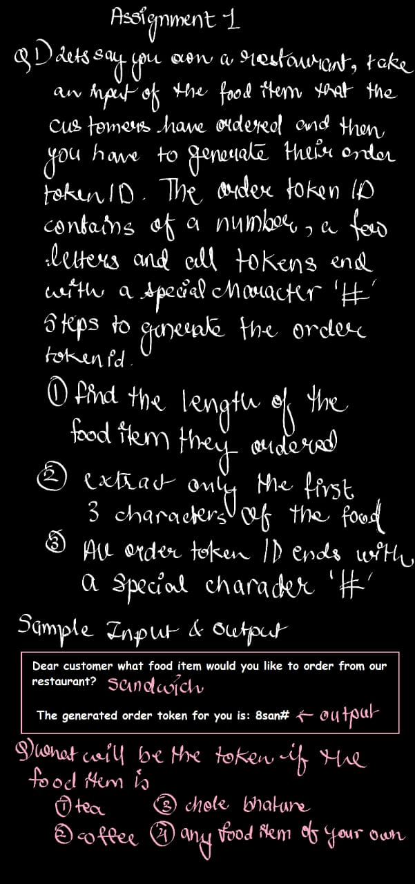

#QUESTION 1

S=input(“Enter coustemer orderded item:”)

Print(str(len(s))+str(s[:3])+’#’)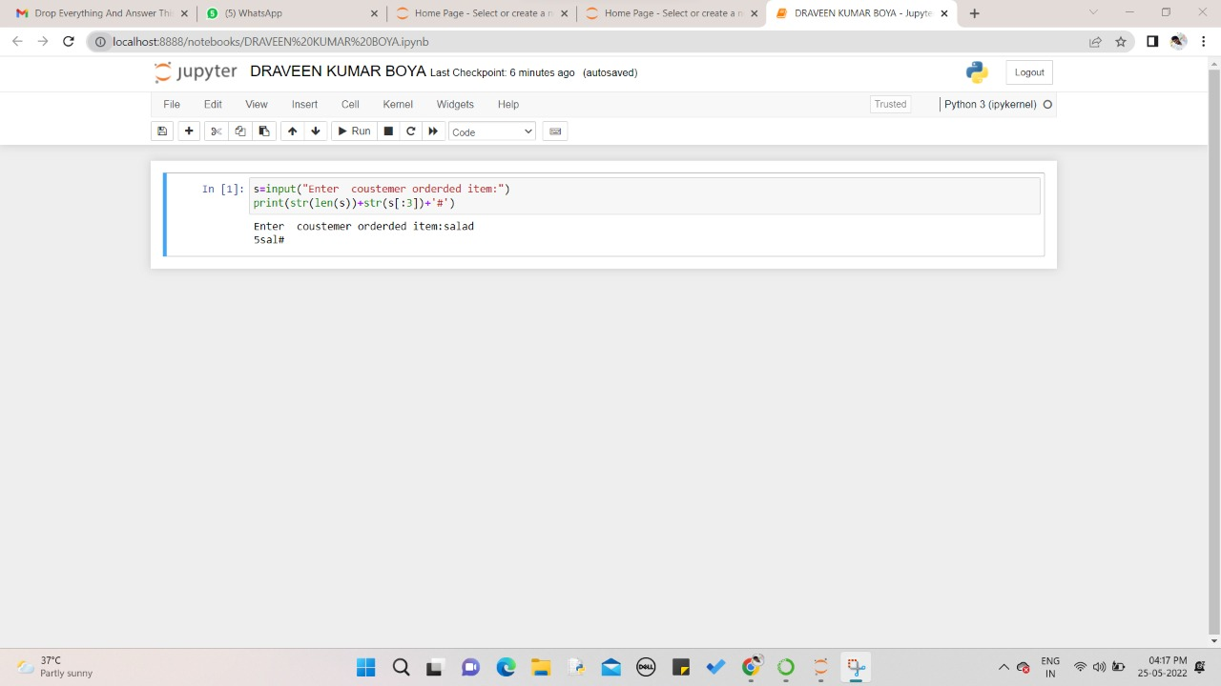

Sample Input:salad

Sample Output:5sal#

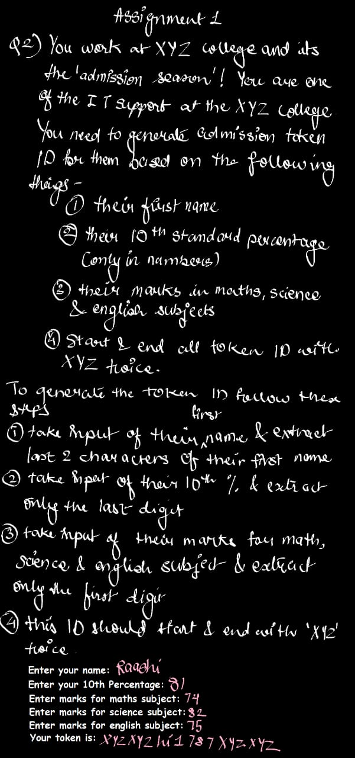

#QUESTION 2

Name=input(“Enter your name:”)

Ten=int(input(“Enter your 10th percentage:”))

Maths=int(input(“Enter Marks for Maths subject:”)) #QUESTION 2

Science=int(input(“Enter Marks for Science subject:”))

English=int(input(“Enter Marks for English subject:”))

Print(“Your token is:”+”XYZ”\*2+name[-2:]+str(ten%10)+str(Maths//10)+str(Science//10)+str(English//10)+’XYZ’\*2)

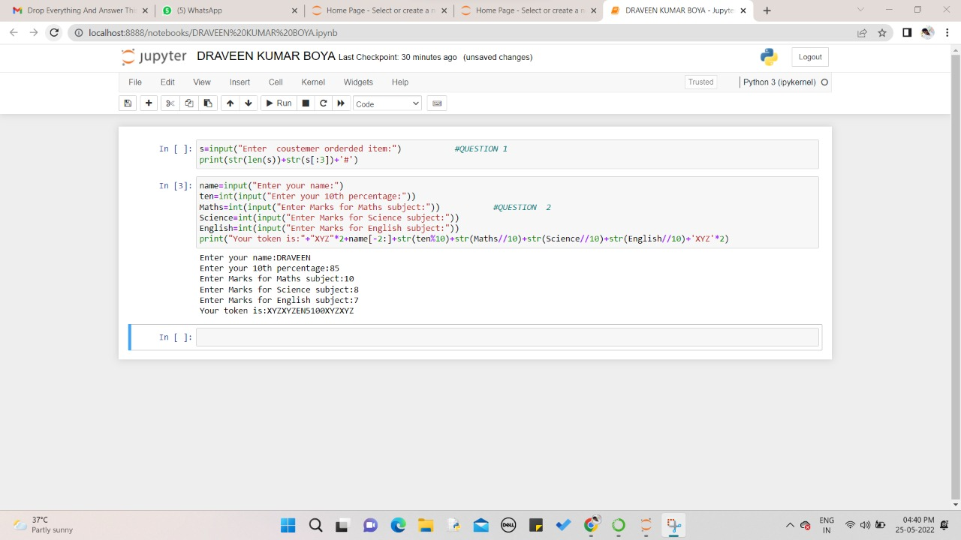

Sample Input:

Enter your name:DRAVEEN

Enter your 10th percentage:85

Enter Marks for Maths subject:10

Enter Marks for Science subject:8

Enter Marks for English subject:7

Sample Output:

Your token is:XYZXYZEN5100XYZXYZ